***Chemistry***

**15: Equilibria of Other Reaction Classes**

**15.2: Lewis Acids and Bases**

61. Under what circumstances, if any, does a sample of solid AgCl completely dissolve in pure water?

Solution

when the amount of solid is so small that a saturated solution is not produced

63. Calculate the cadmium ion concentration, [Cd2+], in a solution prepared by mixing 0.100 L of 0.0100 *M* Cd(NO3)2 with 1.150 L of 0.100 NH3(*aq*).

Solution

Cadmium ions associate with ammonia molecules in solution to form the complex ion , which is defined by the following equilibrium:



The formation of the complex ion requires 4 mol of NH3 for each mol of Cd2+. First, calculate the initial amounts of Cd2+ and of NH3 available for association:





For the reaction, 4.00  10–3mol/L of Cd2+ would require 4(4.00  10–3 mol/L) of NH3 or a 1.6  10–2-*M* solution. Due to the large value of *K*f and the substantial excess of NH3, it can be assumed that the reaction goes to completion with only a small amount of the complex dissociating to form the ions. After reaction, concentrations of the species in the solution are

[NH3] = 6.00  10–2 mol/L – 1.6  10–2 mol L–1 = 4.4  10–2 *M*

Let *x* be the change in concentration of [Cd2+]:

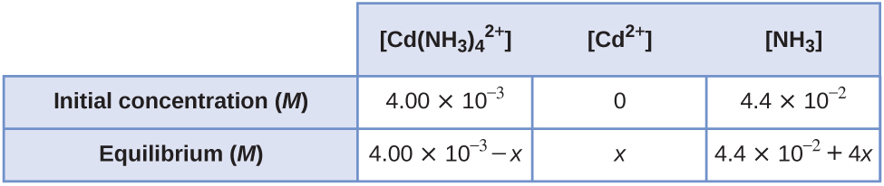





As *x* is expected to be about the same size as the number from which it is subtracted, the entire expression must be expanded and solved, in this case, by successive approximations where substitution of values for *x* into the equation continues until the remainder is judged small enough. This is a slightly different method than used in most problems. We have:

1.3  107*x* (4.4  10–2 + 4*x*)4 = 4.00  10–3 – *x*

1.3  107*x* (3.75  10–6 + 1.36  10–3*x* + 0.186*x*2 + 11.264*x*3 + 256*x*4) = 4.00  10–3

16*x* + 5440*x*2 + 7.44  105*x*3 + 4.51  107*x*4 + 1.024  109*x*5 = 4.00  10–3

Substitution of different values *x* will give a number to be compared with 4.00  10–3. Using 8  10-5 gives 4.01  10-3, this is a good fit. Thus 8  105 is close enough to the true value of *x* to make the difference equal to zero. The decision to drop 4*x* compared with 4.4 x 10-2 is justified.

65. Sometimes equilibria for complex ions are described in terms of dissociation constants, *K*d. For the complex ion  the dissociation reaction is:

and 

Calculate the value of the formation constant, *K*f, for .

Solution

For the formation reaction:



67. Using the dissociation constant, *K*d = 7.8  10–18, calculate the equilibrium concentrations of Cd2+ and CN– in a 0.250-*M* solution of .

Solution

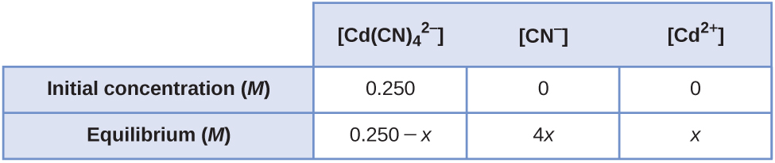



Assume that *x* is small when compared with 0.250 *M*.

256*x*5 = 0.250  7.8  10–18

*x*5 = 7.617  10–21

*x* = [Cd2+] = 9.5  10–5 *M*

4*x* = [CN–] = 3.8  10–4 *M*

69. Using the dissociation constant, *K*d = 2.2  10–34, calculate the equilibrium concentrations of Co3+ and NH3 in a 0.500-*M* solution of .

Solution

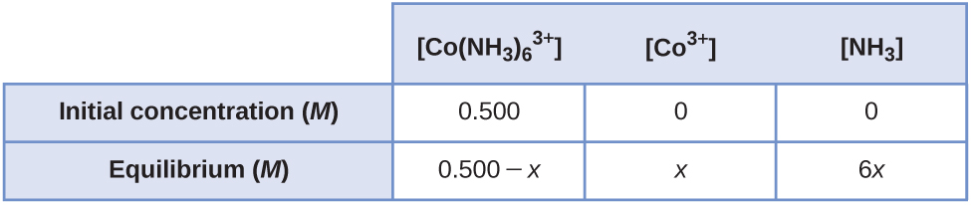



Assume that *x* is small when compared with 0.500 *M*.

4.67  104*x*7 = 0.500  2.2  10–34

*x*7 = 2.358  10–39

*x* = [Co3+] = 3.0  10–6 *M*

6*x* = [NH3] = 1.8  10–5 *M*

71. Calculate the mass of potassium cyanide ion that must be added to 100 mL of solution to dissolve 2.0  10–2 mol of silver cyanide, AgCN.

Solution

Because *K*sp is small and *K*f is large, most of the Ag+ is used to form ; that is:



The CN– from the dissolution and the added CN– exist as CN–and . Let *x* be the change in concentration upon addition of CN–. Its initial concentration is approximately 0.

[CN–] + 2 = 2  10–1 + *x*

Because *K*sp is small and *K*f is large, most of the CN– is used to form ; that is:

.



2(2.0  10–1) – 2.0  10–1 = *x*

2.0  10–1 *M*  L = mol CN– added

The solution has a volume of 100 mL.

2  10–1 mol/L  0.100 L = 2  10–2 mol

mass KCN = 2.0  10–2 mol KCN  65.120 g/mol = 1.3 g

73. A roll of 35-mm black and white photographic film contains about 0.27 g of unexposed AgBr before developing. What mass of Na2S2O3.5H2O (sodium thiosulfate pentahydrate or hypo) in 1.0 L of developer is required to dissolve the AgBr as  (*K*f = 4.7  1013)?

Solution

The reaction is governed by two equilibria, both of which must be satisfied:



The overall equilibrium is obtained by adding the two equations and multiplying their *K*s:



If all Ag is to be dissolved, the concentration of the complex is the molar concentration of AgBr.

formula mass (AgBr) = 187.772 g/mol



Let *x* be the change in concentration of :

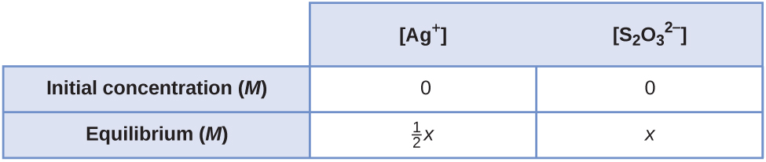



*x*2 = 8.799  10–8



The formula mass of Na2S2O3·5H2O is 248.13 g/mol. The total  needed is:

2(1.438  10–3) + 2.97  10–4 = 3.173  10–3 mol

g(hypo) = 3.173  10–3 mol  248.13 g/mol = 0.79 g

75. Write the Lewis structures of the reactants and product of each of the following equations, andidentify the Lewis acid and the Lewis base in each:

(a) 

(b) 

(c) 

(d) (use Al-Cl single bonds)

(e) 

Solution

(a) 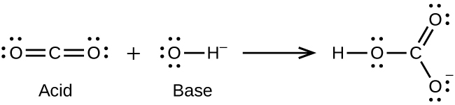;

(b) 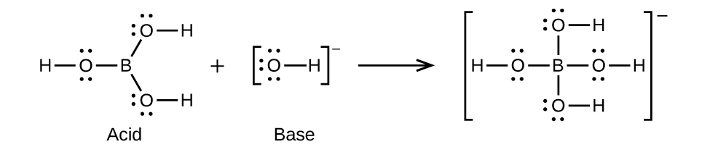;

(c) 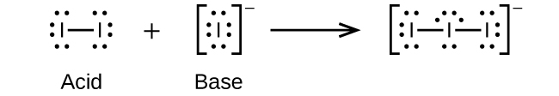;

(d) 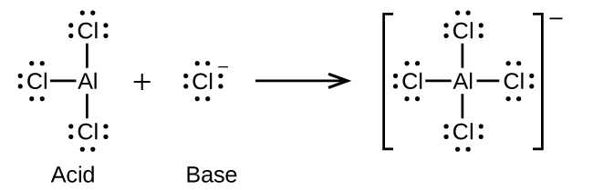;

(e) 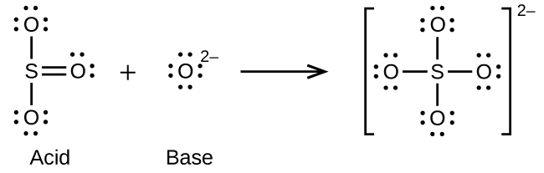

77. Using Lewis structures, write balanced equations for the following reactions:

(a) 

(b) 

(c) 

(d) 

Solution

(a) 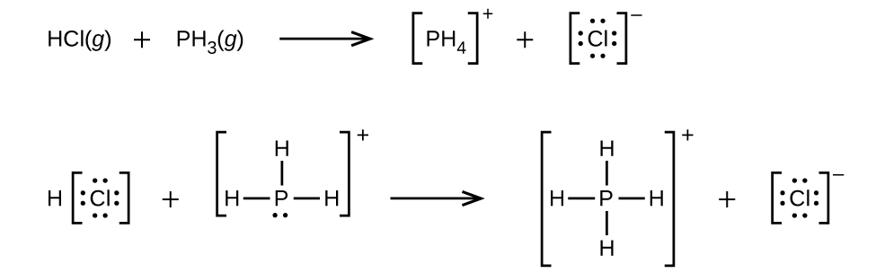;

(b) 

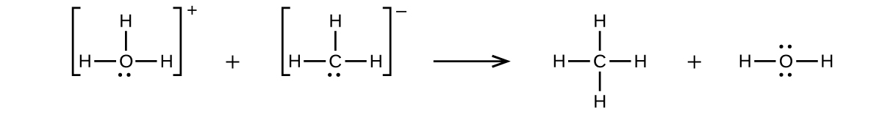;

(c) 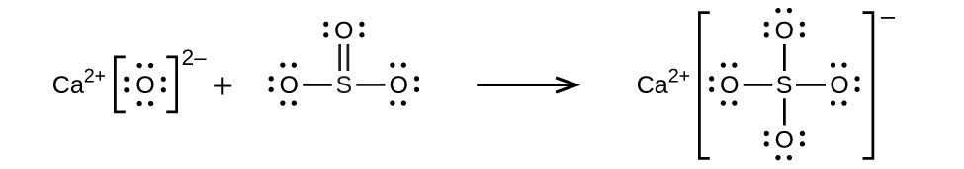;

(d) 

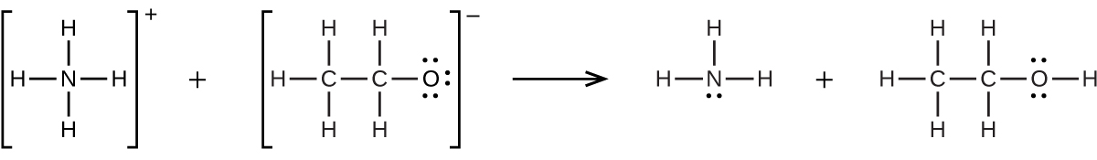

79. In a titration of cyanide ion, 28.72 mL of 0.0100 *M* AgNO3 is added before precipitation begins. [The reaction of Ag+ with CN– goes to completion, producing the  complex.] Precipitation of solid AgCN takes place when excess Ag+ is added to the solution, above the amount needed to complete the formation of . How many grams of NaCN were in the original sample?

Solution

The equilibrium is:



The number of moles of AgNO3 added is:

0.02872 L  0.0100 mol/L = 2.87  10–4 mol

This compound reacts with CN– to form , so there are 2.87  10–4 mol. This amount requires 2  2.87  10–4 mol, or 5.74  10–4 mol, of CN–. The titration is stopped just as precipitation of AgCN begins:



so only the first equilibrium is applicable. The value of *K*f is very large.

mol CN– < []

mol NaCN = 2 mol [] = 5.74  10–4 mol



81. In dilute aqueous solution HF acts as a weak acid. However, pure liquid HF (boiling point = 19.5 °C) isa strong acid. In liquid HF, HNO3 acts like a base and accepts protons. The acidity of liquid HF canbe increased by adding one of several inorganic fluorides that are Lewis acids and accept F– ion (for example, BF3 or SbF5). Write balanced chemical equations for the reaction of pure HNO3 with pure HF and of pure HF with BF3.

Solution

; 

83. Boric acid, H3BO3, is not a Brønsted-Lowry acid but a Lewis acid.

(a) Write an equation for its reaction with water.

(b) Predict the shape of the anion thus formed.

(c) What is the hybridization on the boron consistent with the shape you have predicted?

Solution

(a) ; (b) First, form a symmetrical structure with the unique atom, B, as the central atom. Then include the 32e–to form the Lewis structure: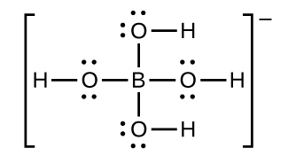

Because there are four bonds and no lone pair (unshared pair) on B, the electronic and molecular shapes are the same—both tetrahedral. (c) The tetrahedral structure is consistent with *sp*3 hybridization.

This resource file is copyright 2015, Rice University. All Rights Reserved.